**PEMBAGIAN TUGAS**

**ELMA(E-Learning Informatika)**

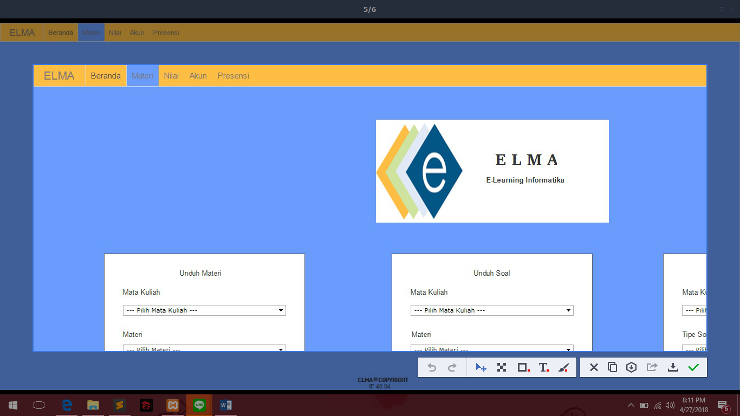

Anggota Kelompok:

* Ariani Fitria(1301164155)
* Deryandaru Bhaskara(130116239)
* Fatkha Nuansa(1301164006)
* Raden Muhamad Irvan R(1301164339)

|  |  |
| --- | --- |
| Tugas | Nama Anggota |
| SKPL | * Raden Muhamad Irvan R * Deryandaru Bhaskara |
| DPPL | * Raden Muhamad Irvan R |
| Mockup(Prototype) | * Deryandaru Bhaskara * Ariani Fitria * Fatkha Nuasa |
| Sequence Diagram | * Ariani Fitria * Fatkha Nuasa * Deryandaru Bhaskara * Raden Muhamad Irvan R |
| Use Case | * Ariani Fitria * Fatkha Nuansa * Deryandaru Bhaskara |
| Use Case Scenario | * Deryandaru Bhaskara * Raden Muhamad Irvan R |
| ERD | * Ariani Fitria * Fatkha Nuasa * Deryandaru Bhaskara |
| Component Diagram | * Raden Muhamad Irvan R |
| Slide Presentasi | * Ariani Fitria * Fatkha Nuansa |
| Activity Diagram | * Deryandaru Bhaskara * Raden Muhamad Irvan R |